# CODE-COMPILE

1. Add link to git repository

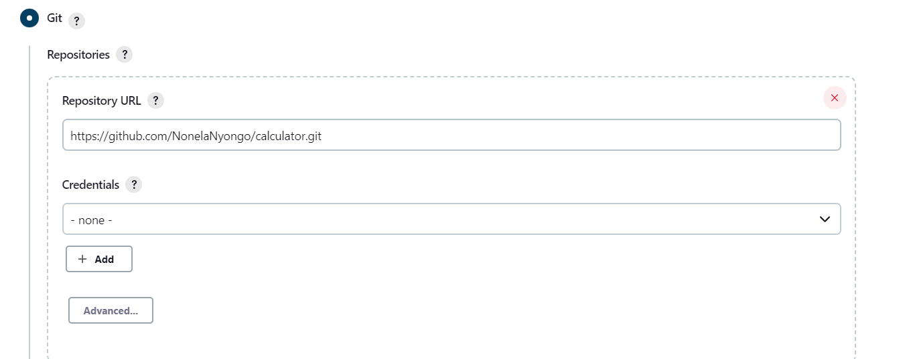

1. Add maven goal

SAV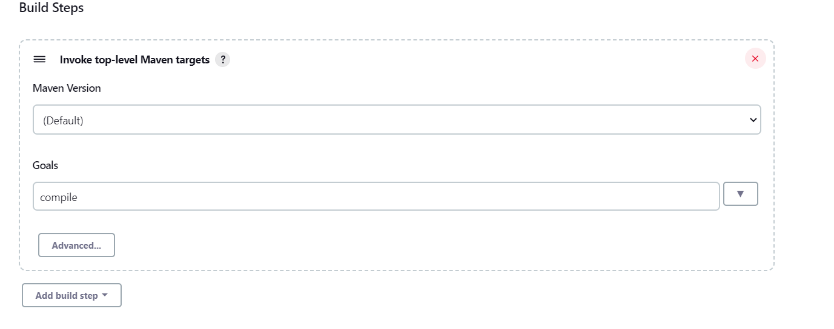

SAVE

BUILD NOW

## CODE-TEST

1. Create New Item

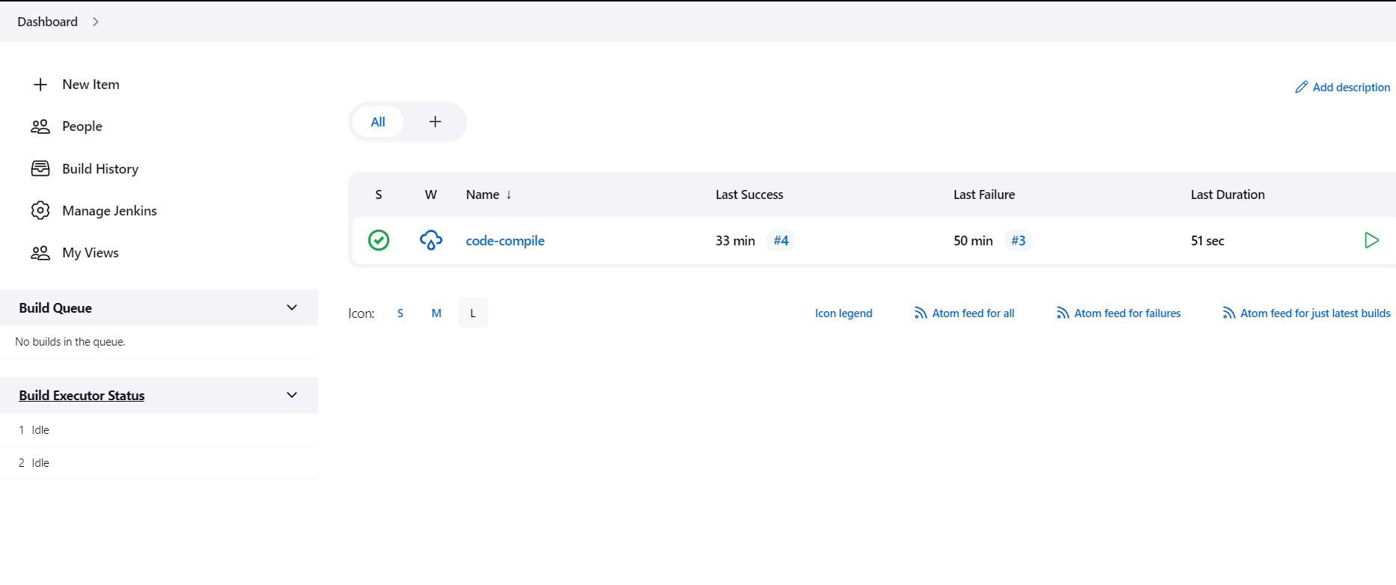

1. Enter name and select freestyle project

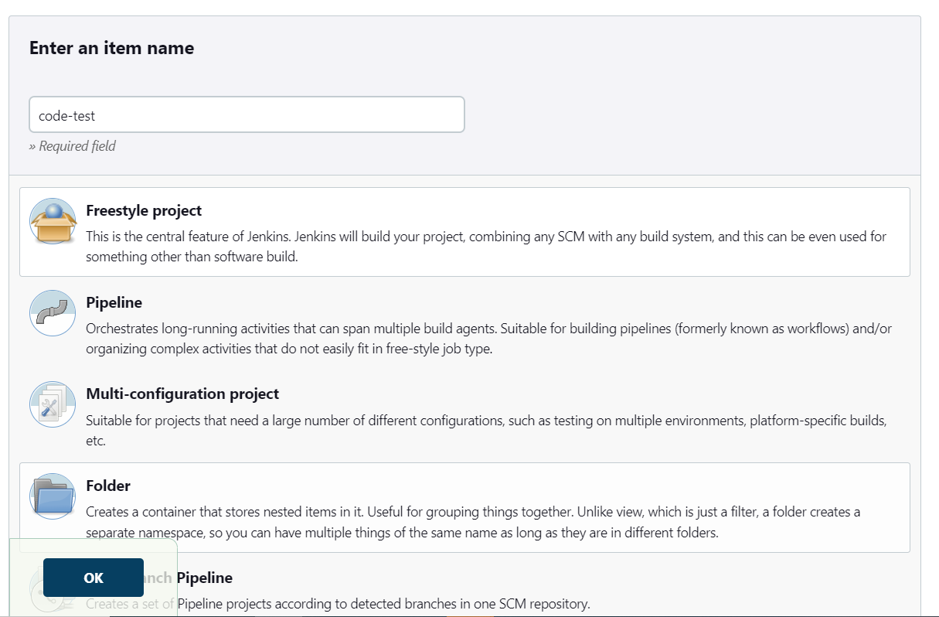

1. Add git repository



1. Add build trigger

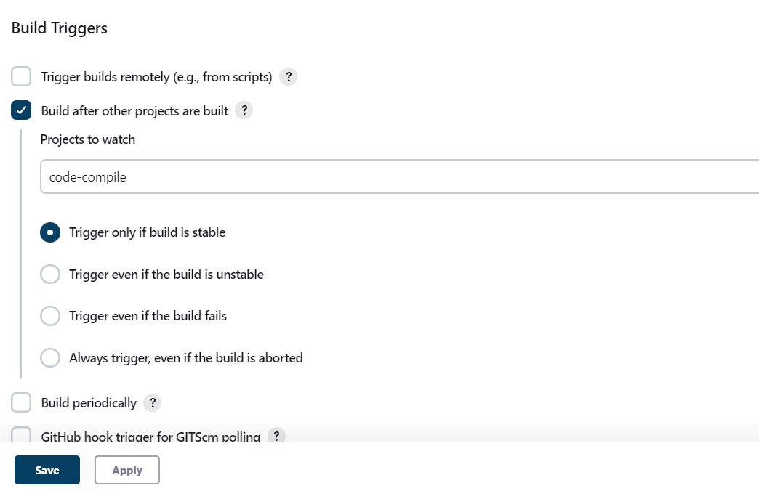

1. Add build step and maven goal

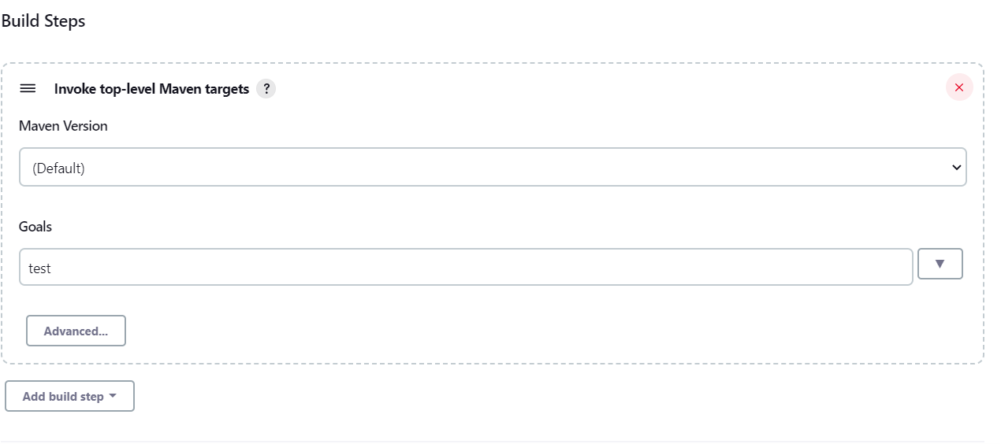

SAVE

BUILD NOW

## CODE-QUALITY

1. Follow step 1, 2 and 3 of code-test example.
2. Add build trigger

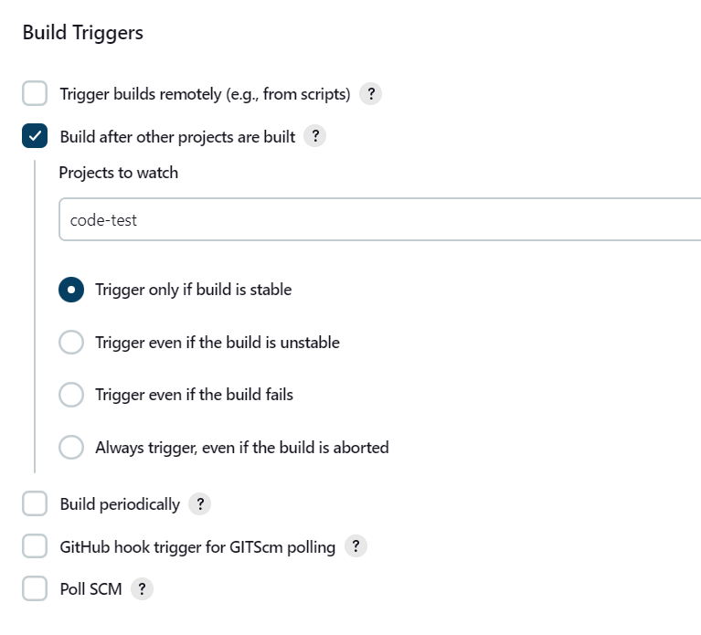

1. Add build step and set maven goal

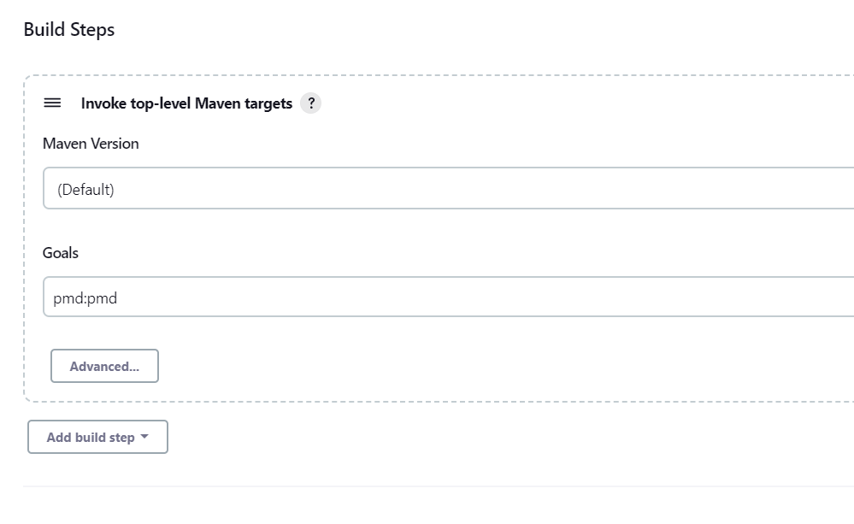

SAVE

BUILD NOW

# PACKAGE

1. Follow step 1, 2 and 3 of code-test
2. Set build trigger

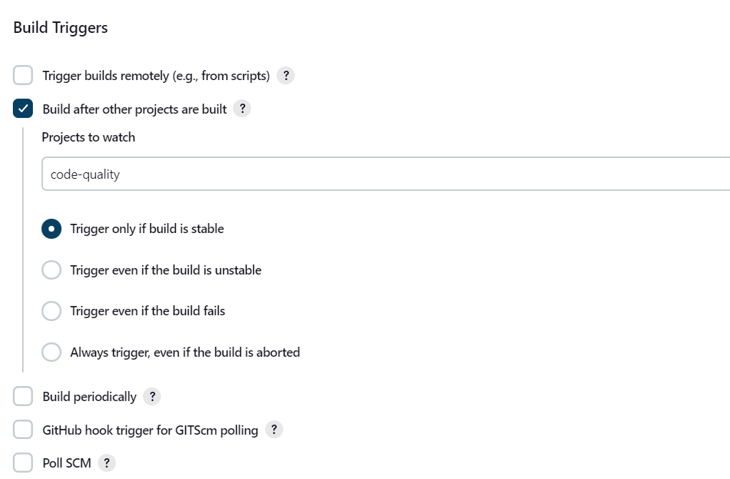

1. Set build step and maven goal

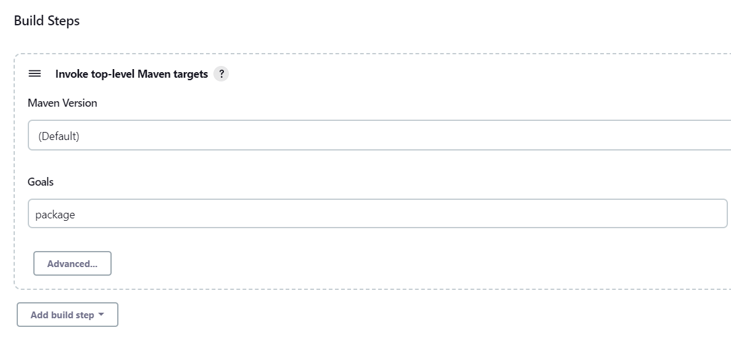

SAVE

BUILD NOW

# NEW VIEW

1. 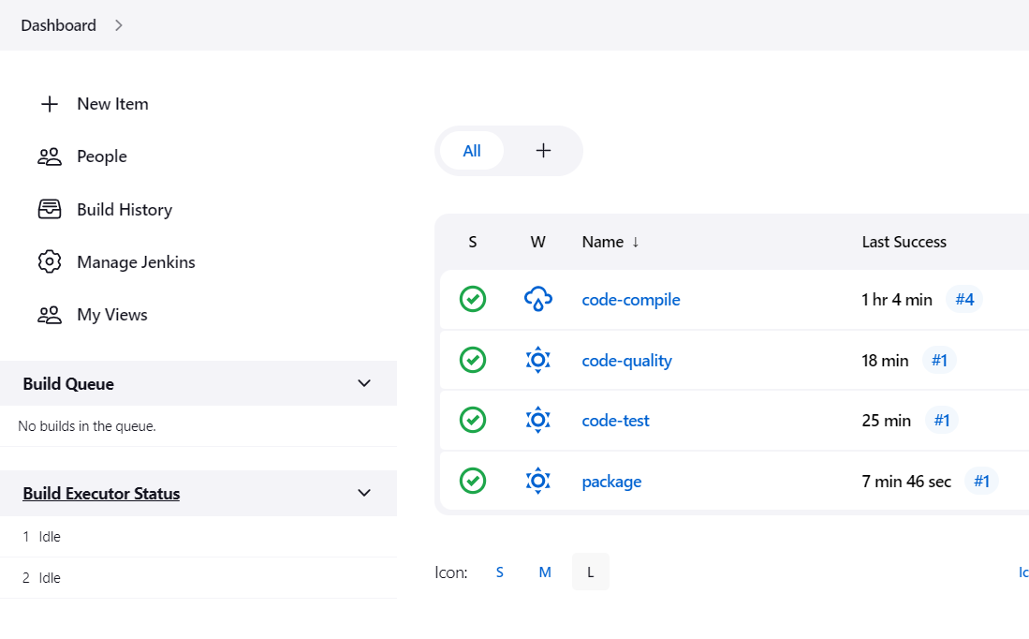Install build pipeline package

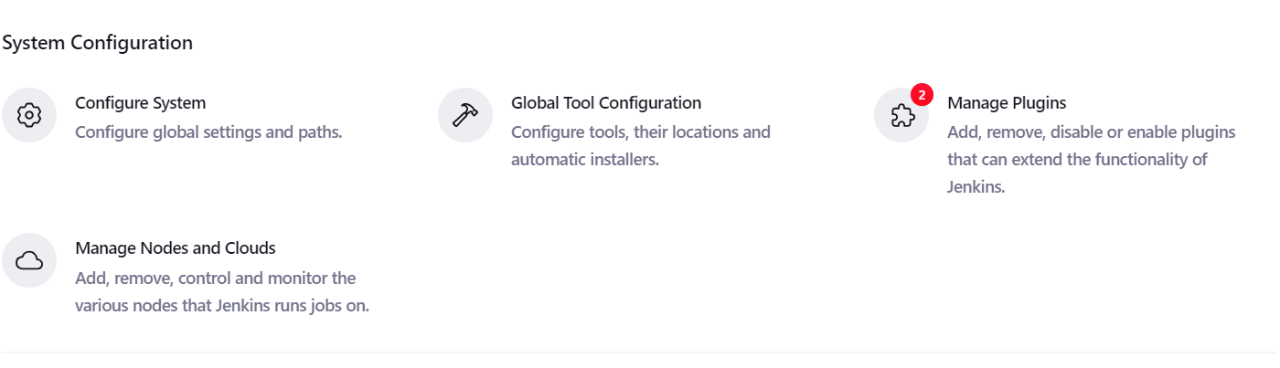

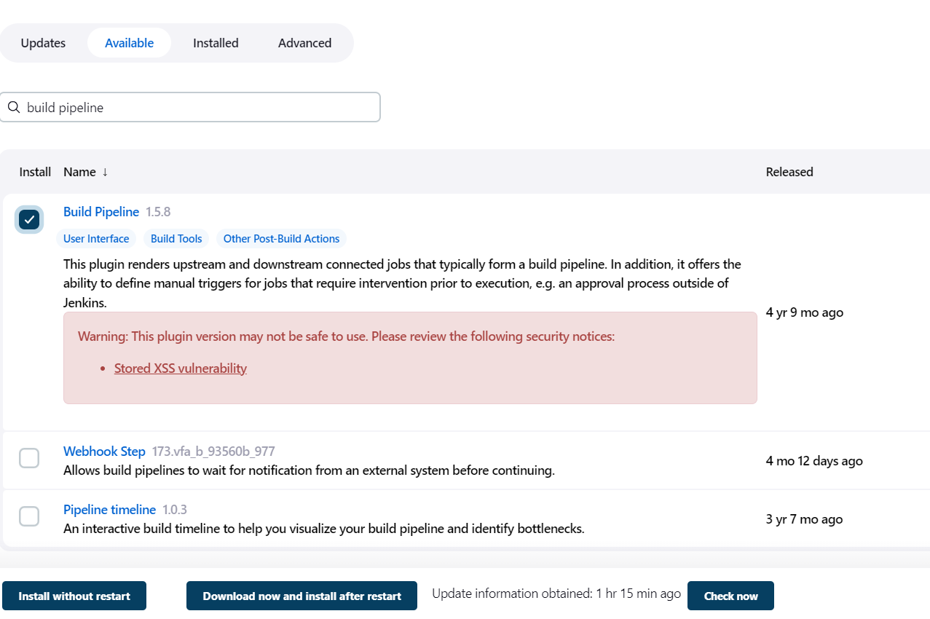

1. Create new view

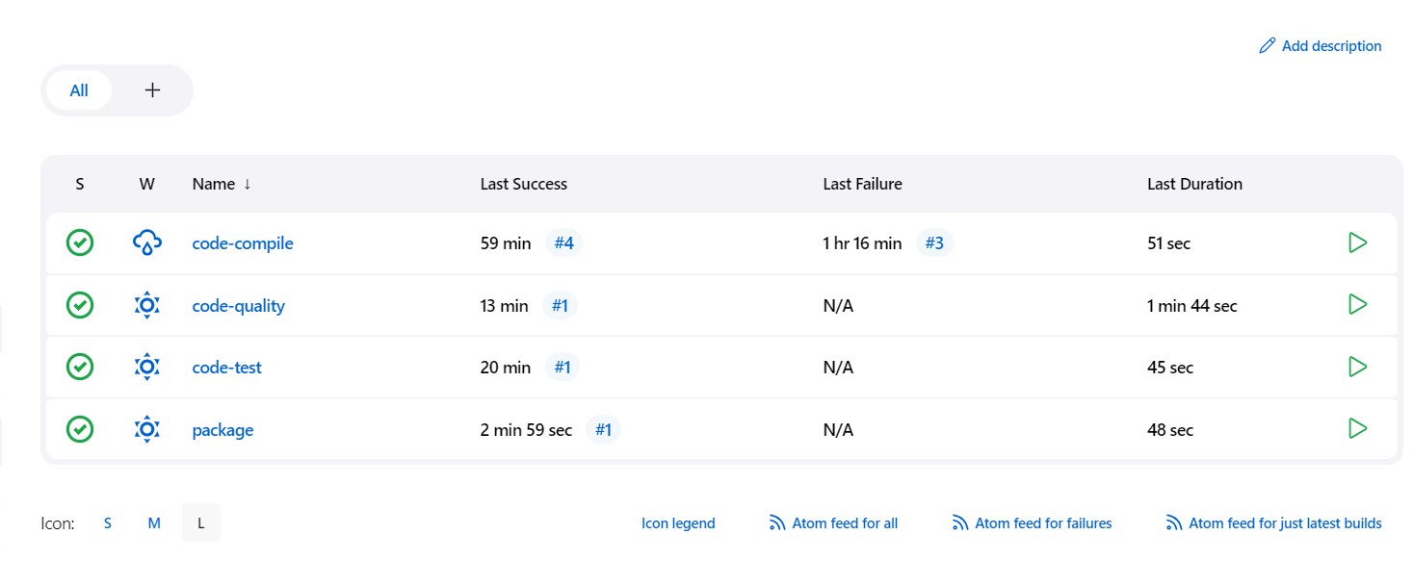

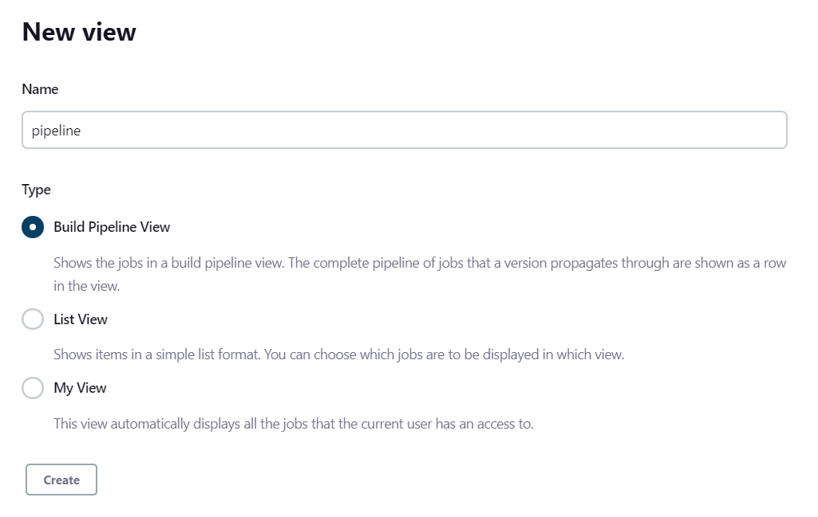

SELECT OK

